UNIVERSITI TEKNOLOGI MALAYSIA
SOFTWARE ENGINEERING DEPARTMENT
Project Creation in C++
______________________________________________________________________________

- Start Dev-C++
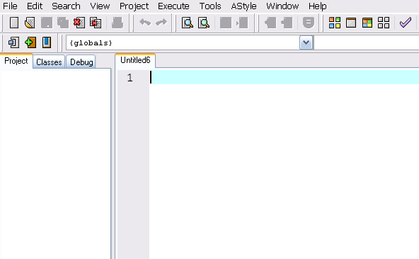

- On the main menu, click File -- New -- Project.

- On the New Project dialog box, click the Project property sheet if necessary.
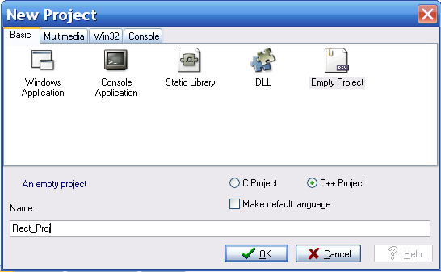
Click on Empty Project.
Give a name to your project. A default name: Project1 is given. You can change this name later.

- Click OK. Next you will be asked to create a location for the project.

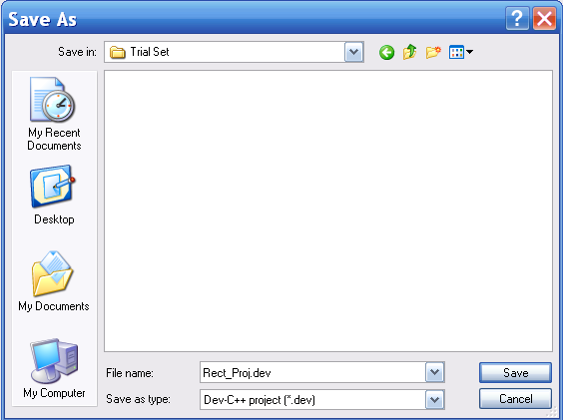 | 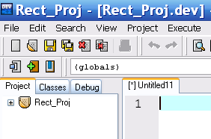

- Right click on Project icon and choose Add to Project. Click once.
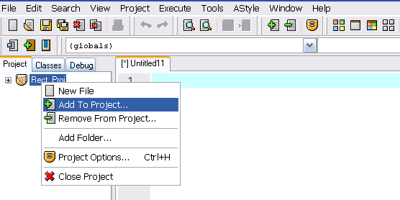

- Given a dialog box as below, choose the driver program in our case Rect_App.cpp
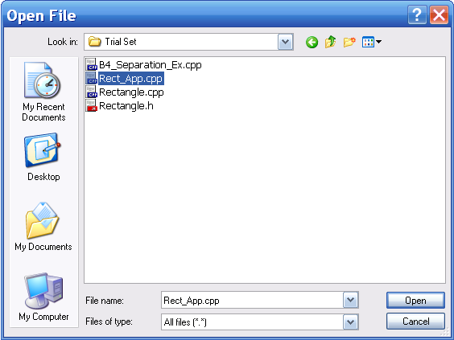
Click Open. You will see that Rect_App.cpp has been added to the RectProj file.

- Repeat steps 5 and 6 to add in the implementation (Rectangle.cpp) and specification / header (Rectangle.h) files.
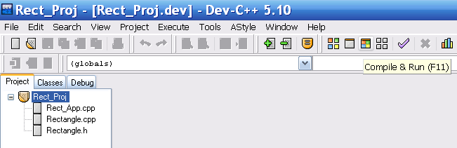

- The project allows you to execute more than one source files at a time. Compile & Run as usual. This will produce a file of .dev type


- Because the project has already been saved, it is better to save your C++ files as you go.

- Observe that even though we have 3 source files, it is executed as if it is one. This is enabled because of its linkage between the driver, implementation and specification files.

